Jira tool set up :

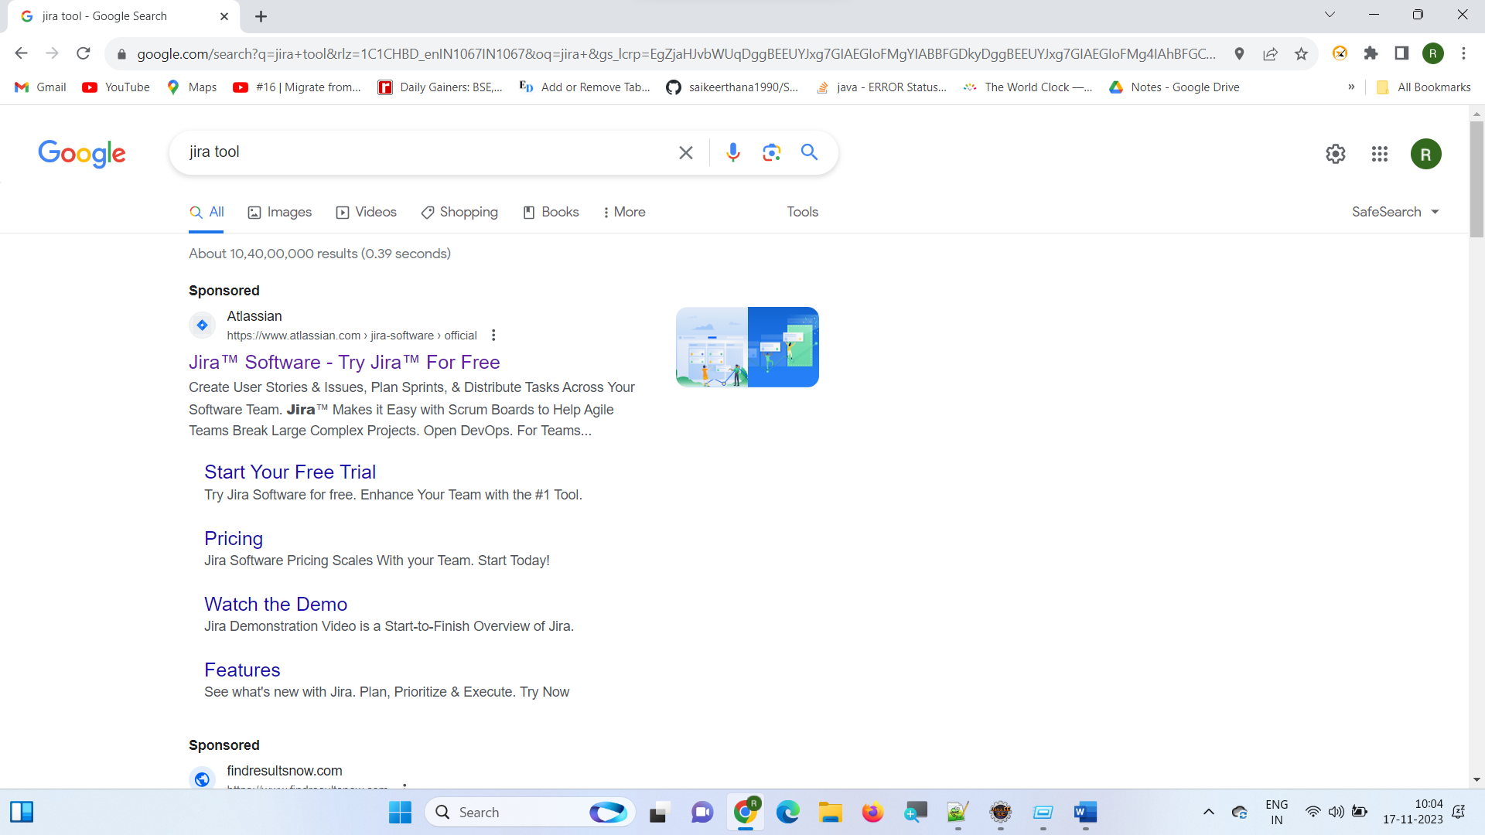

<https://www.atlassian.com/try/cloud/signup?bundle=jira-software&edition=free&signupSource=skipBundles>

